Saint John's Episcopal Church
The Episcopal Anglican Church
serving all of Jones County since 1898
Welcomes You!

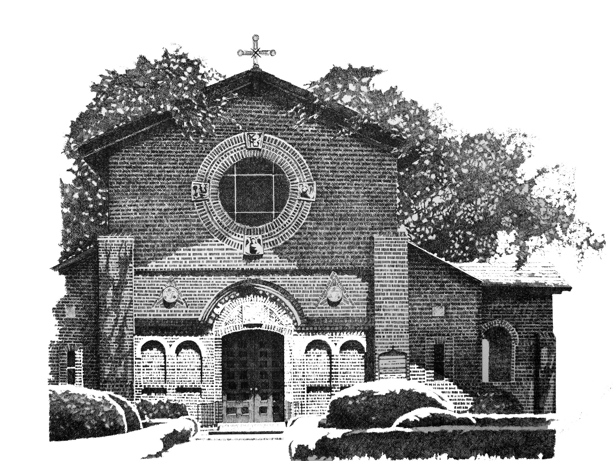

A Manual of Instruction
for the
Guild of Ushers

On behalf of the people of Saint John’s Episcopal Church, I want to thank you for your dedication to the ministry and service of being an Usher.

The ministry of the usher is one of hospitality- seeing that communicants and guests of the Church are taken care of and comfortable, and that the service is a meaningful and edifying.

The ministry of the usher is to help insure order, both in regard to the state and condition of the Church, and in the movement of the people who come to worship.

The ushers, in overseeing the bringing up of the Bread and Wine and in bringing forth offerings of money and other gifts, serve the people of God by bringing forth the gifts offered to God for use in the Holy Eucharist and in the work and mission of the Church on their behalf.

So, it is a very important ministry you have agreed to undertake…it is one of service to God, and hospitality and servant-hood to His people. This manual is designed to give you guidelines and expectations and make your service to this parish one that meaningful for both you and those whom you serve.

Beloved, it is a loyal thing you do when you render any service to the brethren, especially to strangers, who have testified to your love before the church. You will do well to send them on their journey as befits God's service. (III John 1.5-6 RSV)

Again thank you and God bless you for your willingness to serve Our Lord.

Duties and Expectations

Before the service

- Arrive at Church at least fifteen minutes before service
  - Take a moment to pray when you arrive at church, thanking God for your share in this ministry, and asking God to bless the people you will meet and to use you as an instrument of Christ’s hospitality…never forgetting the people of this parish, her sick and shut in, and the dead.
- Make sure books are in pew racks.
  - There should be at least two Books of Common Prayer and two Hymnal 1982 in each section of pew, the hymnals should be in the middle and the BCPs on the outside of the hymnals
- Make sure pews are free of debris and items left over from the previous service.
- About twelve minutes before the service, each usher should take up station at one of the three doors of the Nave, with two ushers at the back or main entrance of the Nave.
  - Greet those who come in, handing them bulletins, and quietly welcoming them to Church.
  - if they are new to the Saint Johns, help seat them and show them how to use the Bulletin or the BCP and Hymnal and answer any questions they may have. Try and have a member sit with the newcomers to help them during the service…be helpful in any way you see fit.
  - The Ushers by the Side doors and Sacristy Hallway door need to move to the back of the Church about one minute before the service starts.
- During the service, keep an active eye on the congregation. There are rare circumstances when someone will need assistance leaving or have an event that needs attention. As usher, you will be expected to take a leadership role in handling unexpected situations.

Entrance Rite/ Liturgy of the Word

- At least two of the Ushers need to sit on the back pew of the Nave, handing latecomers bulletins and making sure they get a seat. Also, make sure the doors stay closed as late-comers enter.
  - During the summer months it is important to try and keep the doors closed. The air-conditioning cannot overcome the hot and humid outside air and the Nave gets hot and sticky, making for a very uncomfortable day for many.
- After the Gospel reading take a count of those present (including priest, altar party and choir) and write the number of persons on the slip of paper on the back table and give it to the server when you come up to receive the offering basins (before the collection is taken).

The Offertory

- After the Announcements and the Offertory sentence, when the offertory anthem begins
  - shepherd the Oblation Bearers who will carry the Wine and Bread forward- (located on the small table behind the last pew) who will hand them to the server waiting at the altar rail.
    - The Oblation Bearers need to walk together in front of the four ushers walking 2x2. Oblation Bearers will give the elements to the 1st Server and exit out the Sanctuary Door.
    - Then the four ushers step up and retrieve the plates.
  - If there are no Oblation Bearers, the ushers need to take the elements forward.
- When the four ushers arrive at the altar rail, take the offertory plates from the server and walk front to back through the congregation passing the plates from one side of the pew to the other. The idea is for one usher to pass the plate to the person in the pew and have them pass the plate to their neighbor until it reaches the other side and is collected by the other usher. So two ushers will be needed for each side and four plates will be used to collect the offering. Meet the other ushers in the rear of the Church.
- There will be one of two signals that will be used to let the usher know to bring the collection plates forward.
  - If there is a Doxology (Praise God from whom all blessings flow) or Presentation Hymn (congregational music) begin to come forward when the congregation begins to sing.
  - Many times there will be no hymn so wait until the priest instructs the people to stand “please stand” begin to come forward.
- Bring the plates forward two by two, present them to the server, exit out the side door and sit as a group on one of the front pews.

Communion

- As the choir comes to the altar rail to receive communion, please take your positions for communion.
  - One usher will need to station him/herself at the choir steps to monitor traffic and help the elderly up the steps and make sure the altar rail is clearing before allowing the faithful to progress.
    - The idea is to not have crowds of people in the choir because it posses a danger to those exiting the altar rail.
  - One person will need to station him/herself at the bottom of the steps coming down from the altar rail.
    - The duty of this usher is to help the elderly down the steps and to ensure there is not congestion in the hallway due to conversations.
  - The other two ushers will need station themselves at the first pew and usher people from the pews to receive communion.
    - The altar rail will hold around 18 adults. The idea is to allow 18 people to come to communion at one time.
    - To accomplish this, move to the rear of the pew where the 18th person is seated and remain there until altar rail begins to clear. Repeat this process until you reach the back of the Nave.
  - The ushers should be the last people to receive communion. After the last parishioners have begun to walk up, wait 30 seconds or so, and then the two ushers in the back of the Church should follow them up, picking up the usher at the choir steps. The usher at the altar rail steps should come up the steps when the parishioners have exited, at that point the four ushers will all receive communion together.
    - Be sure to tell the priest if there are folks who need communion brought out to them when you come to receive communion.
  - After communion, the ushers should all walk down the isle and then take their places at the doors of the Church.
    - As soon as church is over, the ushers should open all the doors.
    - If there are guests, thank them for coming and encourage them to sign the Guest Book.

Communion

- As the choir comes to the altar rail to receive communion, please take your positions for communion.
  - One usher will need to station him/herself at the choir steps to monitor traffic and help the elderly up the steps and make sure the altar rail is clearing before allowing the faithful to progress.
    - The idea is to not have crowds of people in the choir because it posses a danger to those exiting the altar rail.
  - One person will need to station him/herself at the bottom of the steps coming down from the altar rail.
    - The duty of this usher is to help the elderly down the steps and to ensure there is not congestion in the hallway due to conversations.
  - The other two ushers will need station themselves at the first pew and usher people from the pews to receive communion.
    - The altar rail will hold around 18 adults. The idea is to allow 18 people to come to communion at one time.
    - To accomplish this, move to the rear of the pew where the 18th person is seated and remain there until altar rail begins to clear. Repeat this process until you reach the back of the Nave.
  - The ushers should be the last people to receive communion. After the last parishioners have begun to walk up, wait 30 seconds or so, and then the two ushers in the back of the Church should follow them up, picking up the usher at the choir steps. The usher at the altar rail steps should come up the steps when the parishioners have exited, at that point the four ushers will all receive communion together.
    - Be sure to tell the priest if there are folks who need communion brought out to them when you come to receive communion.
  - After communion, the ushers should all walk down the isle and then take their places at the doors of the Church.
    - As soon as church is over, the ushers should open all the doors.
    - If there are guests, thank them for coming and encourage them to sign the Guest Book.

After the service

- Help pick up bulletins left in pews and place them on the back table.
- Look for any items left in pews, and if found, take them to the parish office.
- Help make sure books are back in the rack and orderly.
- Turn off the Air handling units.
  - All of the units on the walls should be turned to the off position except for the first unit on each side of the Nave which in summer months should be set to 78 degrees and in winter months should be set to 65.
    - There is one unit on the wall of the choir by the Altar door. Please turn the toggle switch to the off position.
    - There is one unit on the wall in the sacristy hallway. Please turn this unit off.
    - There is one unit in the Vestry (the room the acolytes and priest vest). Please make sure this unit is off.
  - Turn off all lights
    - In the fuse box closest to the Nave turn off the fuse labeled sacristy
    - In the fuse box furtherest from the Nave:
      - Turn off the four light switches that control the Nave chandeliers.
      - Turn off the dimmer switch for the Choir:
        - Make sure it is turned all the way off, it will click when it is in the off position.
      - Turn off the dimmer for the Sanctuary.
      - Turn the small gear on the timer to turn off the side lights. It is important that only the gear is used to turn these lights on or off. The dimmer switch needs to remain in the on position and in the brightest position because these lights come on at night so people can come in and pray.
  - Remove flowers from altar and take them to the office hallway so that the pastoral care committee can take them to the sick and shut in. (If they stay in the church, they will die from heat).
  - Say a prayer of thanksgiving and enjoy the rest of your day!

Ushering for Weddings

Before the Service

- Make sure lights are on at least 30 minutes before service.
- Make sure flags are out at least 30 minutes before service.
- Make sure acolytes has candles lit by 20 minutes before service.
- Adjust thermostats accordingly (in summer months, it can never be cold enough, and in the winter, with an empty Church, we want it cooler, so keep the temperature below 65- trust me, it will be hotter than that.
- Help with Photographer
  - The Photographer is supposed to be finished with pictures well before the wedding- in most cases 30 minutes, please help the Wedding committee ensure that this is not violated.
  - Photography is only allowed from the rear of the Church and when the couple is at the altar rail, from inside the altar door (hidden from site). Please help make sure this is honored. Many times the photographer will walk all over the church taking pictures and causing a distraction. Please take the time to go over the rules with them before the service.
- Oversee honorary ushers at the rear of the Church
  - Keep the honourary ushers in line
    - Most of the time the honorary ushers are not parishineers and many times they are so excited about the festivities that they do not take this job seriously, and they also do not know the church at all, nor do they pay attention at the rehearsal.
      - Make sure they behave
    - Help answer questions:
      - Brides side is on the Pulpit side
      - Grooms side is on Lectern Side
      - Instructions for Restrooms
        - Bride will be in Wicker room
        - Groom will be in Rector’s Office
  - Basically like a Sunday, be ministers of hospitality and set a positive example for others.
- Be attentive to the needs of the Wedding Guild, families and guests.

Communion (if communion there be)

- Much like regular Sunday, but there is no offering, and the ushers should not move to the front of the Church until they are ready to usher the people forward for communion
- Wait until after the Bride and Groom have received communion and as the choir comes to the altar rail to receive communion, please take your positions for communion.
  - Two ushers will need station themselves at the first pew and usher people from the pews to receive communion.
    - The altar rail will hold around 18 adults. The idea is to allow 18 people to come to communion at one time.
    - To accomplish this, move to the rear of the pew where the 18th person is seated and remain there until altar rail begins to clear. Repeat this process until you reach the back of the Nave.
  - The ushers should be the last people to receive communion. After the last parishioners have begun to walk up, wait 30 seconds or so, and then the two ushers in the back of the Church should follow them up.
    - Be sure to tell the priest if there are folks who need communion brought out to them when you come to receive communion.
  - After communion, the ushers should all walk down the isle and then take their places at the doors of the Church.
    - One usher, as soon as the Post Communion prayer begin, needs to walk to the bell and ring it for a period of 5 minutes.
    - As soon as church is over, the other usher should open all the doors.

After the service

- Help pick up bulletins left in pews and place them on the back table.
- Look for any items left in pews, and if found, take them to the parish office.
- Help make sure books are back in the rack and orderly.
- Turn off the Air handling units.
  - All of the units on the walls should be turned to the off position except for the first unit on each side of the Nave which in summer months should be set to 78 degrees and in winter months should be set to 65.
    - There is one unit on the wall of the choir by the Altar door. Please turn the toggle switch to the off position.
    - There is one unit on the wall in the sacristy hallway. Please turn this unit off.
    - There is one unit in the Vestry (the room the acolytes and priest vest). Please make sure this unit is off.
  - Turn off all lights
    - In the fuse box closest to the Nave turn off the fuse labeled sacristy
    - In the fuse box furtherest from the Nave:
      - Turn off the four light switches that control the Nave chandeliers.
      - Turn off the dimmer switch for the Choir:
        - Make sure it is turned all the way off, it will click when it is in the off position.
      - Turn off the dimmer for the Sanctuary.
      - Turn the small gear on the timer to turn off the side lights. It is important that only the gear is used to turn these lights on or off. The dimmer switch needs to remain in the on position and in the brightest position because these lights come on at night so people can come in and pray.
  - Remove flowers from altar and take them to the office hallway so that the pastoral care committee can take them to the sick and shut in. (If they stay in the church, they will die from heat).
  - Say a prayer of thanksgiving and enjoy the rest of your day!

Funerals

Before the Service

- In most cases the body will be received by the priest and laid in state at least one hour before the service. At that time the family will be offered a private moment with the body in the Church and then ushered to the Wicker Room.
  - If possible, help keep the church free of visitors until the private moment is over.
  - Help get the family to the Wicker Room and then make sure water is offered, and they know where the restrooms and kitchen are located.
- Make sure acolytes has candles lit by 20 minutes before service.
- Make sure Reserved Seating velvet signs are out and on front pews for family.
- Usually the family will sit on one side of the Nave in front of the pulpit, but on occasion, we will need to reserve both sides of the front of the Nave.
- Adjust thermostats accordingly (in summer months, it can never be cold enough, and in the winter, with an empty Church, we want it cooler, so keep the temperature below 65- trust me, it will be hotter than that.
- Take up stations at least 20 minutes before service begins
  - Hand out Bulletins
  - Answer questions
  - Immediate Family will be in Wicker Room
  - Know were restrooms are
  - Help seat the elderly.
- At 12 minutes before the service, the priest will say a prayer with the family in the wicker room. After the prayer the ushers should help seat the family (let the funeral home take over handing out bulletins.)
- During the service, please keep a close eye out for events and problems, such as
  - Fainting, being overcome with grief, or other health problems.

Communion (if communion there be)

- Much like regular Sunday, but there is no offering, and the ushers should not move to the front of the Church until they are ready to usher the people forward for communion
- As the choir comes to the altar rail to receive communion, please take your positions for communion.
  - Make sure the family comes to communion first and as a family. Then:
  - Two ushers will need station themselves at the first pew and usher people from the pews to receive communion.
    - The altar rail will hold around 18 adults. The idea is to allow 18 people to come to communion at one time.
    - To accomplish this, move to the rear of the pew where the 18th person is seated and remain there until altar rail begins to clear. Repeat this process until you reach the back of the Nave.
  - The ushers should be the last people to receive communion. After the last parishioners have begun to walk up, wait 30 seconds or so, and then the two ushers in the back of the Church should follow them up.
    - Be sure to tell the priest if there are folks who need communion brought out to them when you come to receive communion.
  - After communion, the ushers should all walk down the isle and then take their places at the doors of the Church.
- After the Committal, when the priest blesses the body, the funeral Directors will assist the Pall Bearers in processing the body to the waiting car.

After the service

- Help pick up bulletins left in pews and place them on the back table.
- Look for any items left in pews, and if found, take them to the parish office.
- Help make sure books are back in the rack and orderly.
- Turn off the Air handling units.
  - All of the units on the walls should be turned to the off position except for the first unit on each side of the Nave which in summer months should be set to 78 degrees and in winter months should be set to 65.
    - There is one unit on the wall of the choir by the Altar door. Please turn the toggle switch to the off position.
    - There is one unit on the wall in the sacristy hallway. Please turn this unit off.
    - There is one unit in the Vestry (the room the acolytes and priest vest). Please make sure this unit is off.
  - Turn off all lights
    - In the fuse box closest to the Nave turn off the fuse labeled sacristy
    - In the fuse box furtherest from the Nave:
      - Turn off the four light switches that control the Nave chandeliers.
      - Turn off the dimmer switch for the Choir:
        - Make sure it is turned all the way off, it will click when it is in the off position.
      - Turn off the dimmer for the Sanctuary.
      - Turn the small gear on the timer to turn off the side lights. It is important that only the gear is used to turn these lights on or off. The dimmer switch needs to remain in the on position and in the brightest position because these lights come on at night so people can come in and pray.
  - Remove flowers from altar and take them to the office hallway so that the pastoral care committee can take them to the sick and shut in. (If they stay in the church, they will die from heat).

